**UI Design**

**Login Screen:**

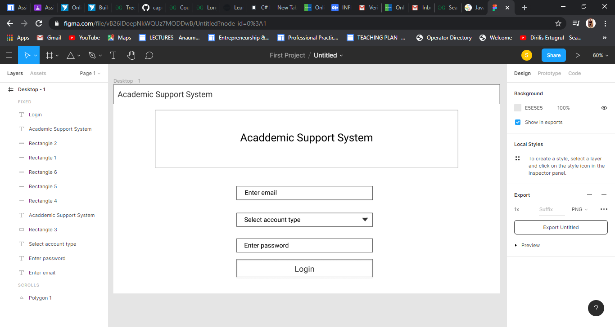

**Dashboard:**

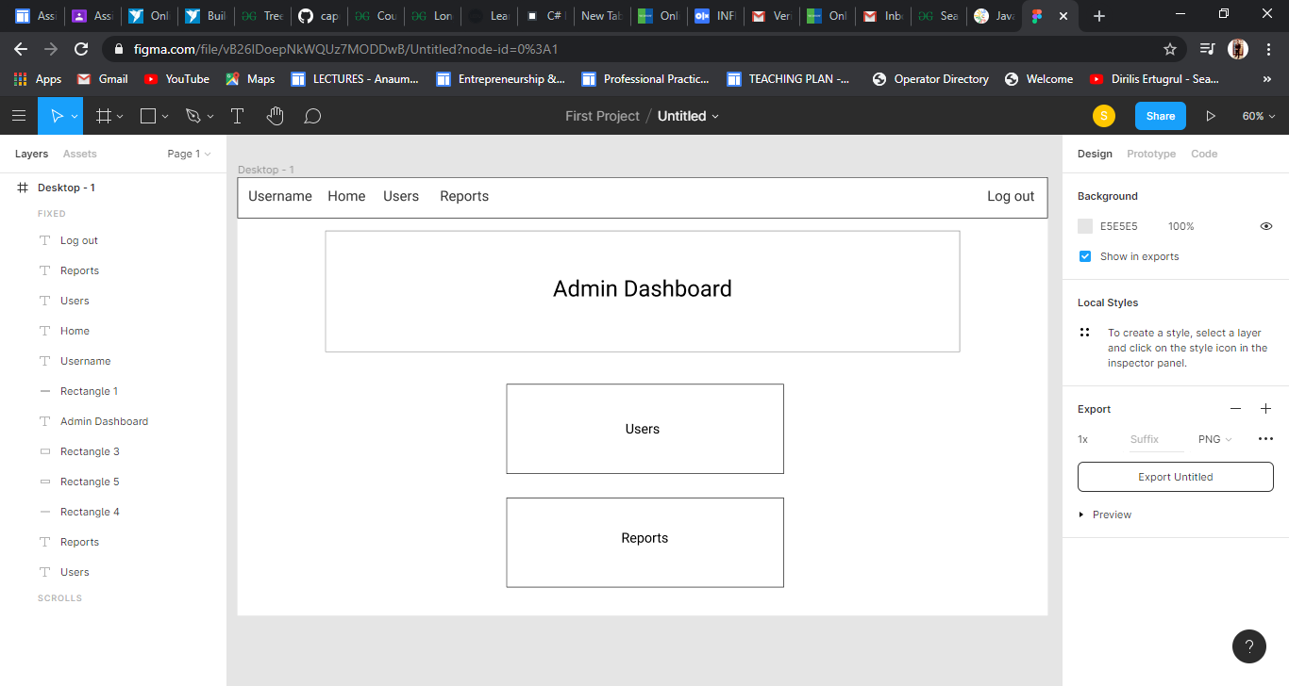

**Other pages:**

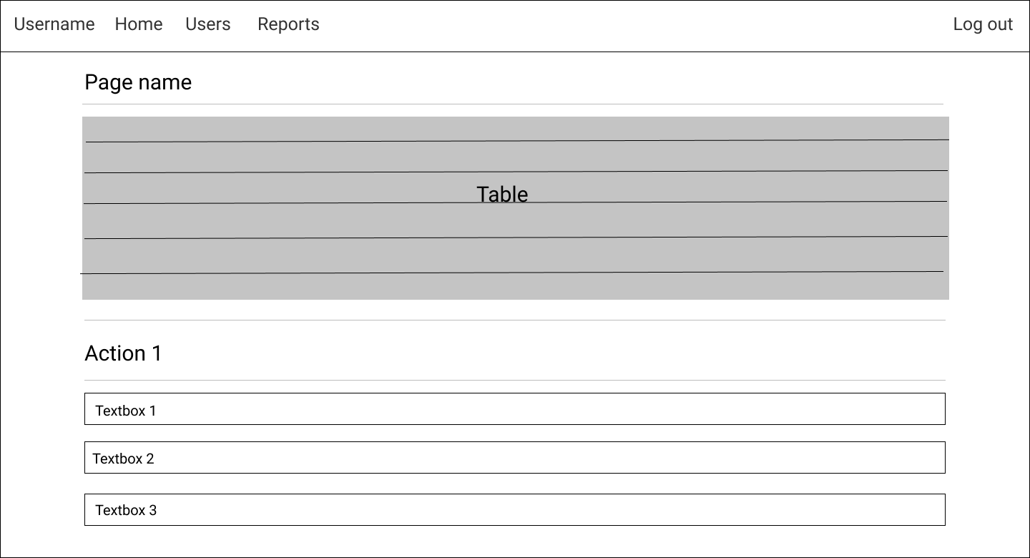

The other pages follow the same Ui design pattern.